Electronic Publications

Academic Personnel will now accept electronic publications with review files. The electronic publications need to be managed locally, but can be done for free by registering for and using a Dropbox account (www.dropbox.com). There are other services out there that you can use as well, but Dropbox seems to be the most widely used file sharing program.

Follow the instructions below to create a unique weblink where the publications can be found. Then, once you have the link, insert it into the Academic Biography/Bibliography (BioBib) after the publications list and before the signature with the comment “New publications marked with * can be found at the following link:” Then place the link. When converting your BioBib to .pdf, the link should show as a hyperlink that reviewers can then click on (or copy and paste if necessary) to find the electronic publications.

Weblink Tutorial

- Create a new folder and title it “FACULTY NAME Publications”. Within this folder, create sub folders for each type of publication the candidate will be submitting. Examples: “JOURNAL ARTICLES”, “CONFERENCE PROCEEDINGS”, and “BOOKS/ BOOK CHAPTERS”
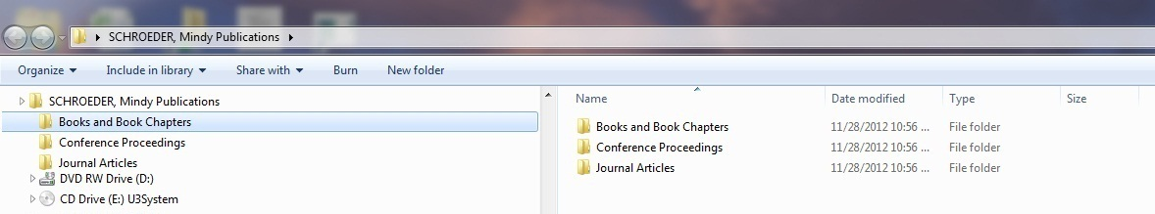

- Save .pdf copies of the candidate’s publications into their respective folders. Name each file with the corresponding number that appears on the BioBib (i.e. A. I. 1, A.III.1).

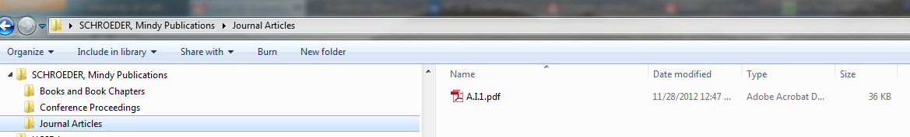

- Open each publication file and type in the location of the publication in the BioBib onto the publication as you would if you were printing hard copies. (In adobe, depending on which version you have – X or XI - you will either click “TOOLS” or “SIGN”. You may have to hit the “content” tab next. Then select Add or Edit Text Box and click the top right corner of the page to begin typing the publication label)

If you using Adobe X Pro
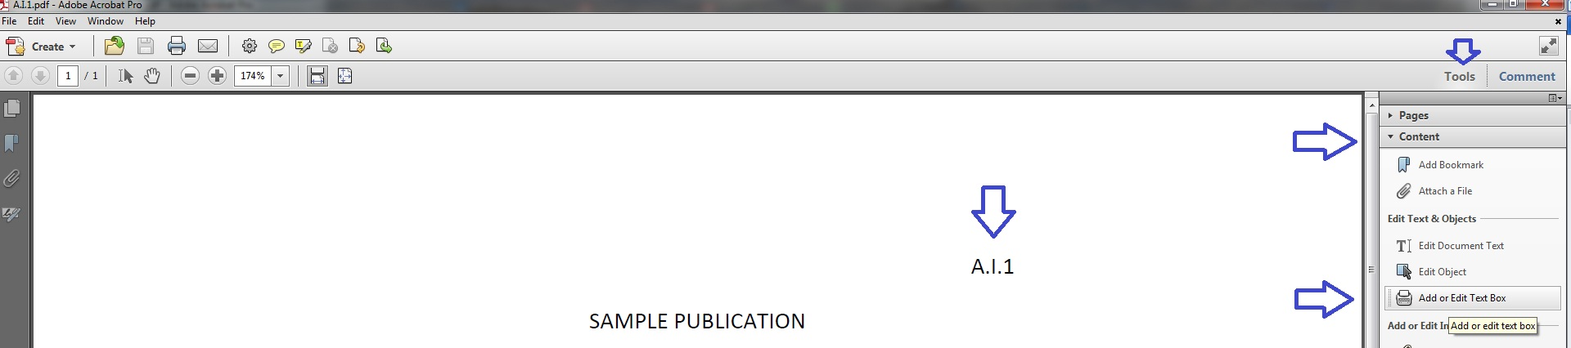

If using Adobe XI Pro
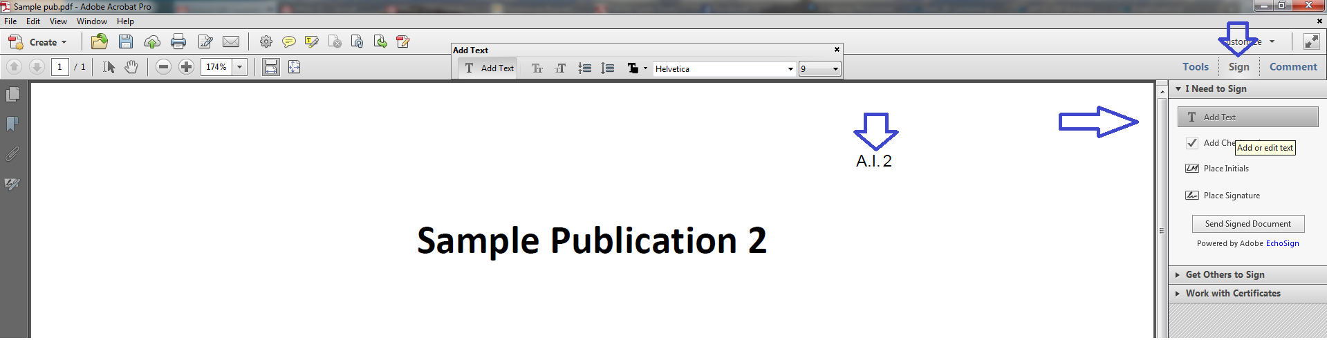

- Once each publication has been labeled, convert the entire FACULTY NAME Publications file into a zip file. If you are not using windows, then you will need to install a winzip program and follow their instruction to zip the file.

- If you are using windows, simply right-click it > send to > compressed (zipped) folder.
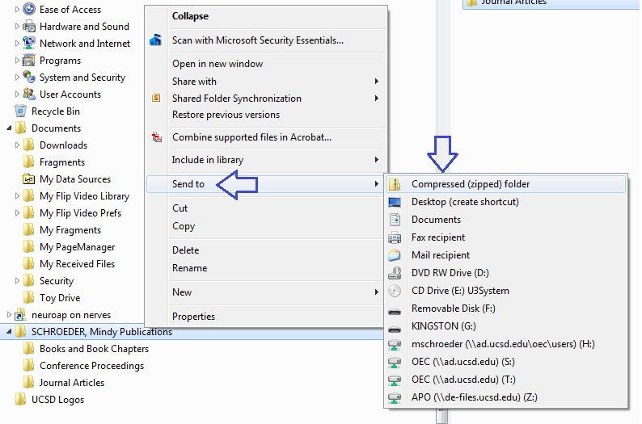

- It will automatically convert and name the folder.
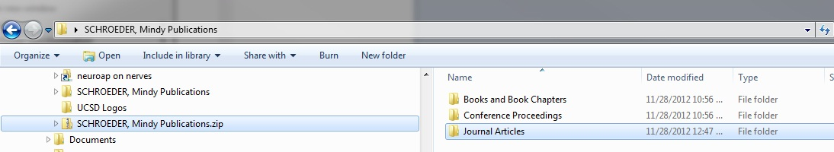

- Go to www.dropbox.com and login. If you do not already have an account, register for one. (They are free!)

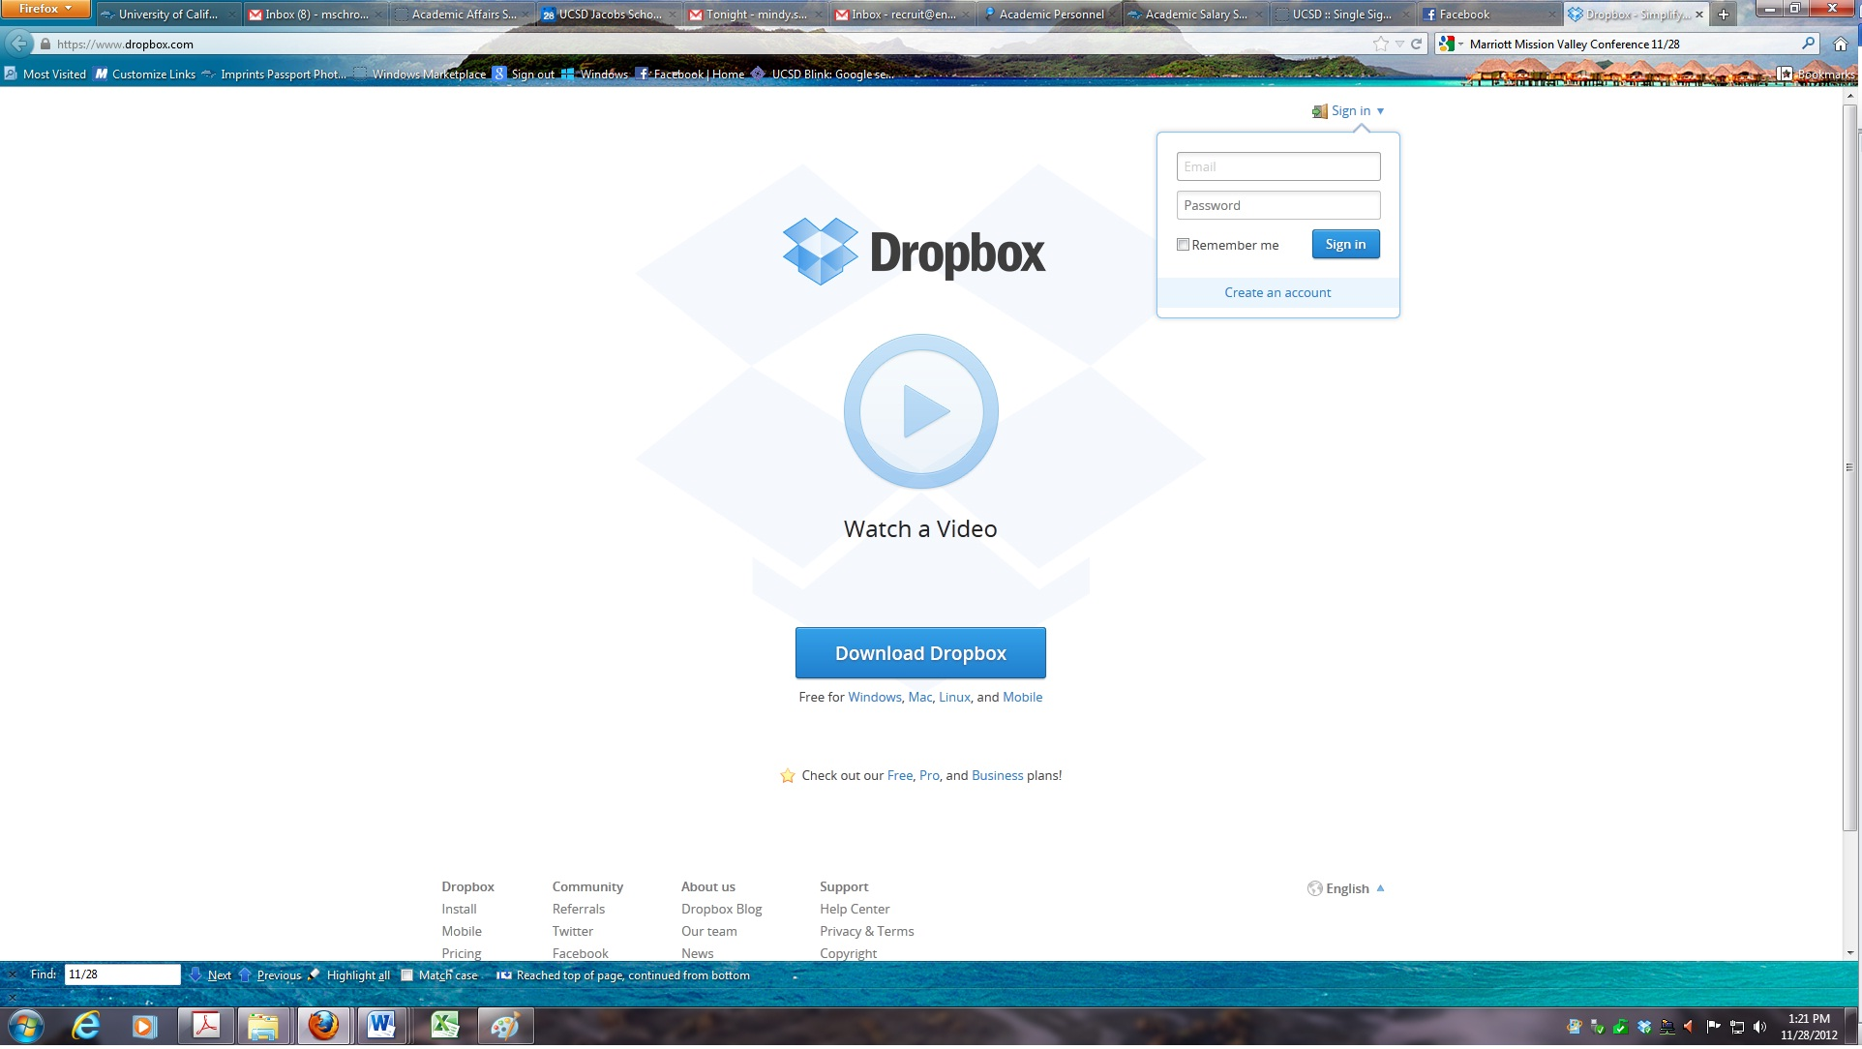

- Upload your new ZIP folder into Dropbox. Make sure the file is placed into the “Public” folder. NOTE: If you installed Dropbox after July of 2012 you will have to create a “Public” folder. See separate instructions below. If you installed it prior to July of 2012, the public folder will already be there for you.

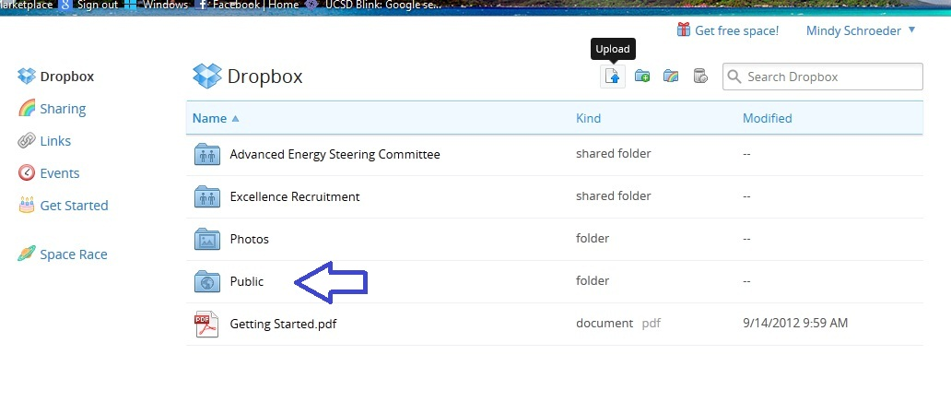

- Open the Public folder and find your Zip file. Right click on it and select “Copy Public Link”.
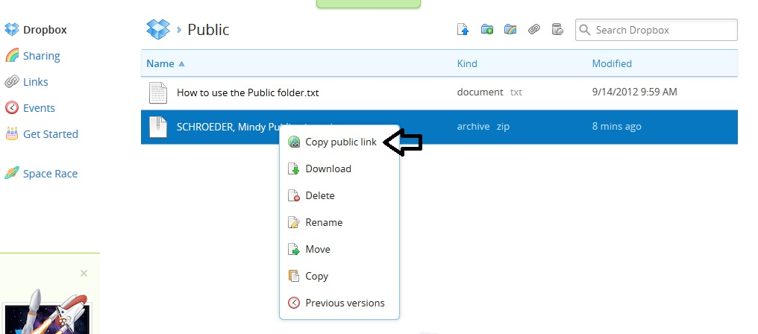

- Cut and paste the link onto the BioBib at the end of the publication list and before the signature line.
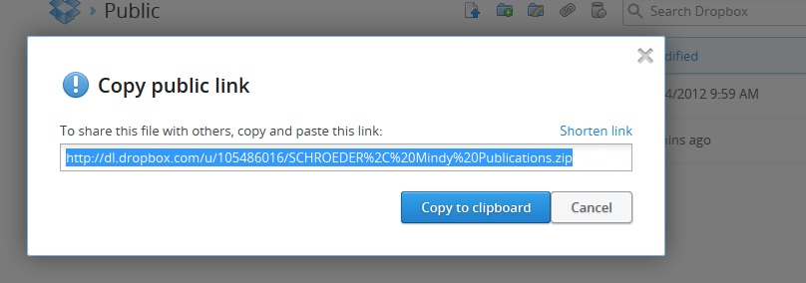

Example:

New publications marked with * can be found at the following link:
http://dl.dropbox.com/u/7766028/FACULTY%20NAME%20Publications.zip

CREATING AND USING A PUBLIC FOLDER IN DROPBOX IF ONE DOES NOT ALREADY EXIST

- Login into dropbox (after you’ve created your account of course)

- Click on the “Drop Box” Icon on the left menu to display your folders. Then click on the new folder icon.
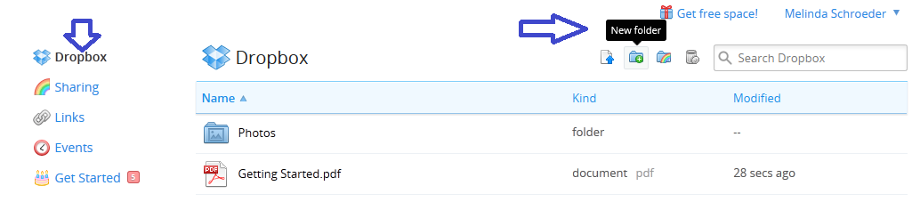

- A new folder will appear with a text field for you to type into. Name this folder “Public”
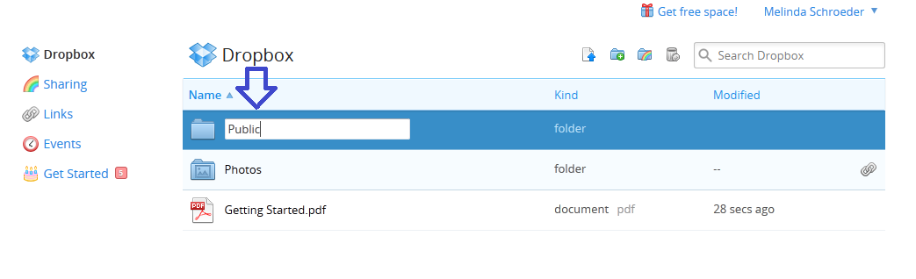

- Open your public folder and upload your compressed file

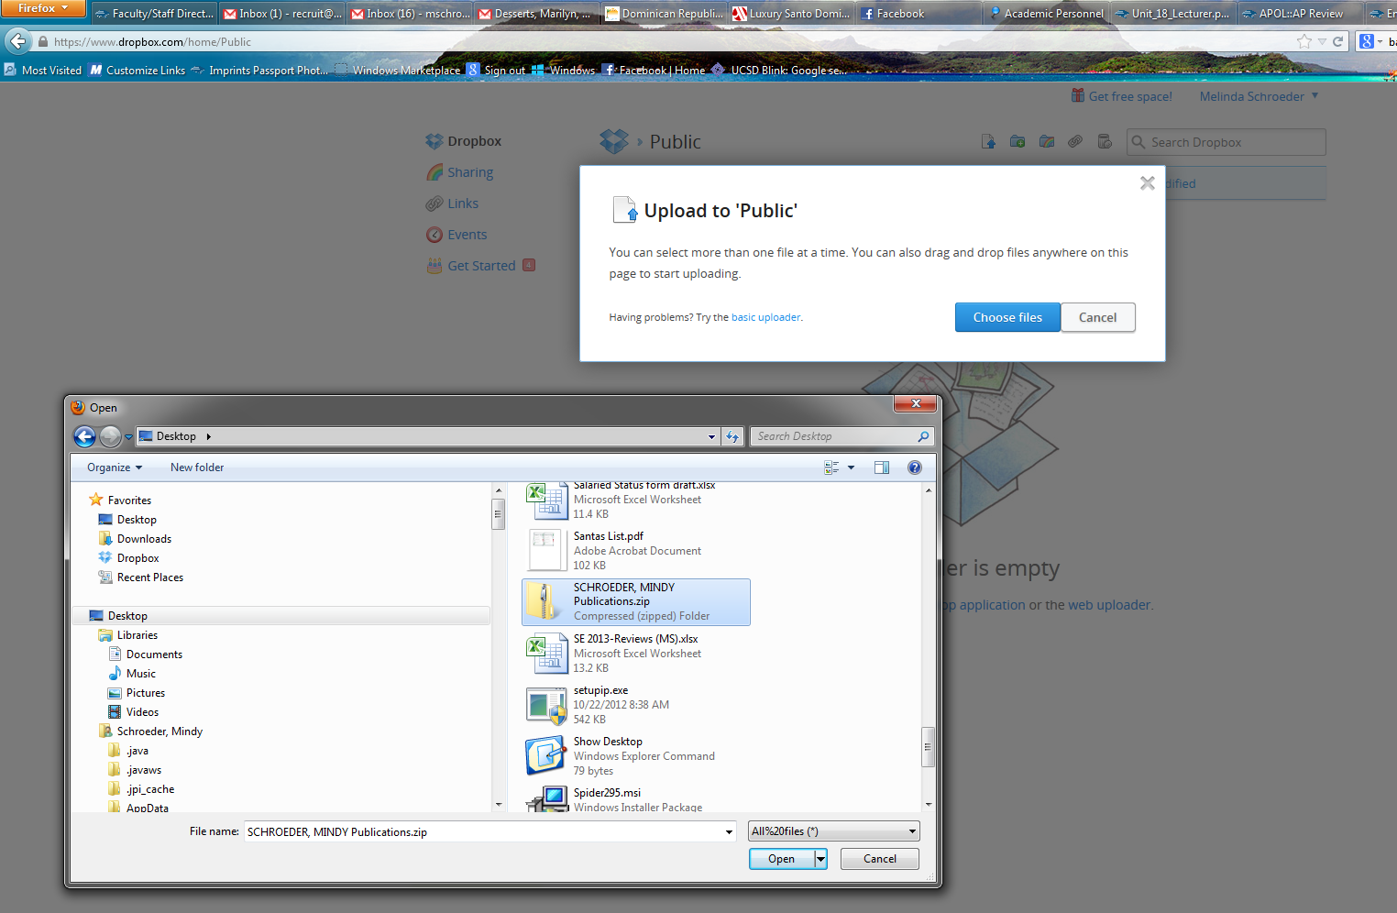

- The compressed file will then appear in your public folder. Right click on it and select “Share Link”.
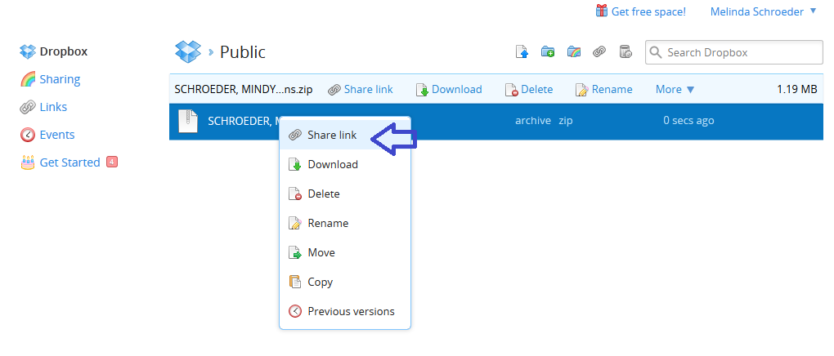

- A dialogue box will appear and will give you the option to enter contacts or to “get link.” Select “get link.”

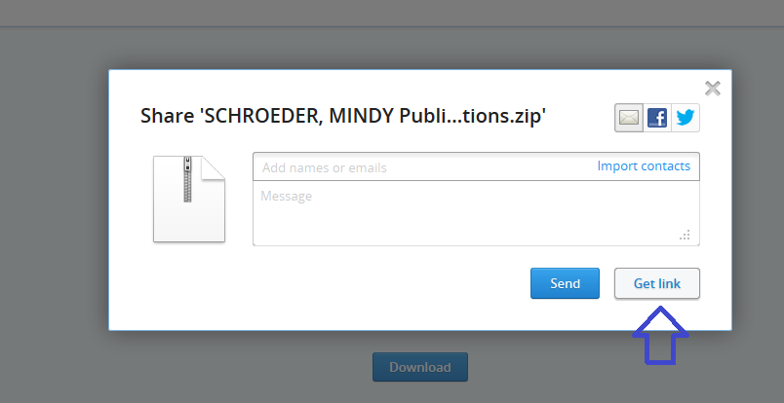

- A new page will open. The web address that shows in the address bar is the link. You can then copy it and paste it into the BioBib as indicated in number 10 above.

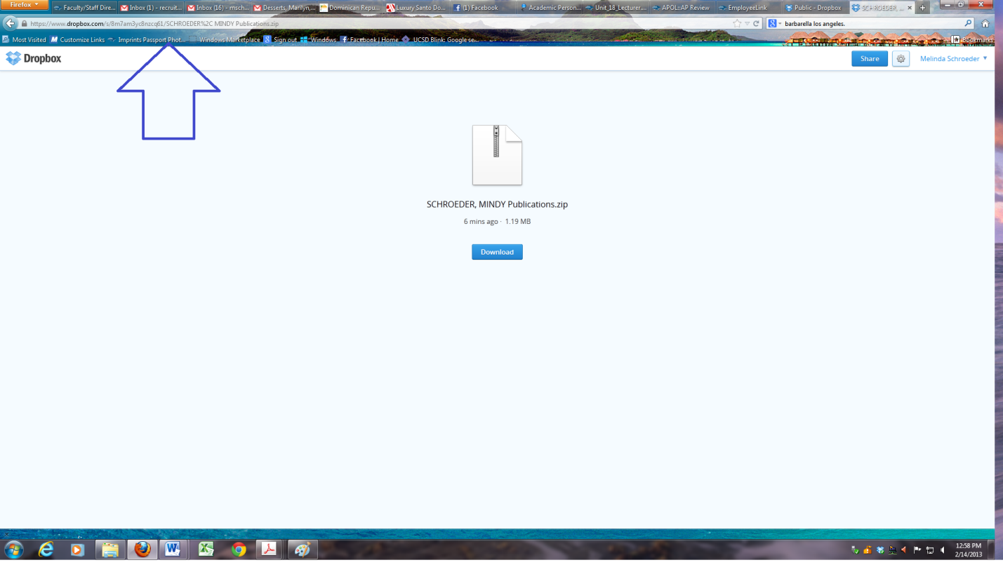

CREATING A LIVE WEBLINK IF A CANDIDATE HAS SIGNED A HARD COPY OF THE BIOBIB

- Scan the signed last page of the biobib and open in Adobe Acrobat Pro.
- Click on the “TOOLS menu and select the “CONTENT EDITING” tab.
- Select “ADD OR EDIT LINK” under “More Content”.
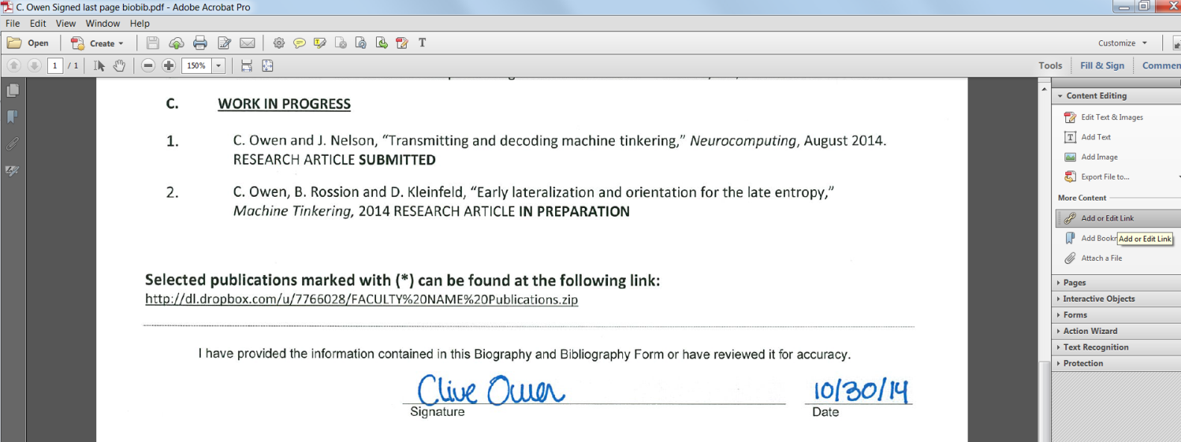
- Using your cursor, select the portion of the scanned page that contains the publication weblink. A “Create Link” pop up menu will appear once you’ve selected the area surrounding the weblink.
- Select “Visible Rectangle” for the link type and “Open a web page” for the link action. It is helpful for reviewer’s to select red or blue as the box outline color so they can easily identify that the weblink is live and clickable. Once you’ve selected each option, hit NEXT.
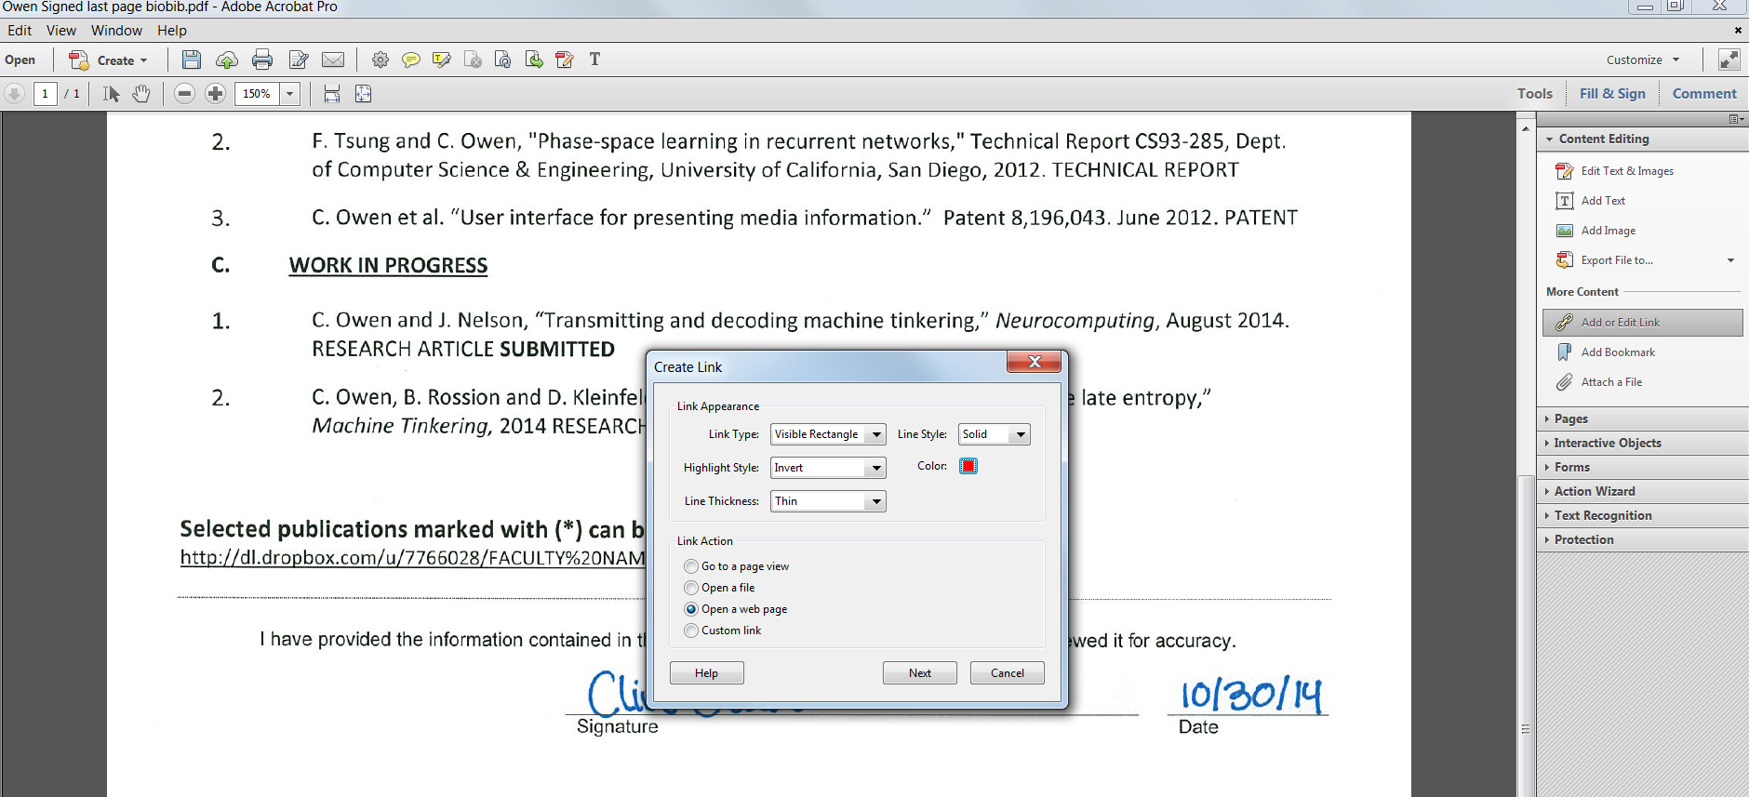

- An “Edit URL” pop up menu will appear. Type in the weblink that houses the candidate’s publication and hit OK.
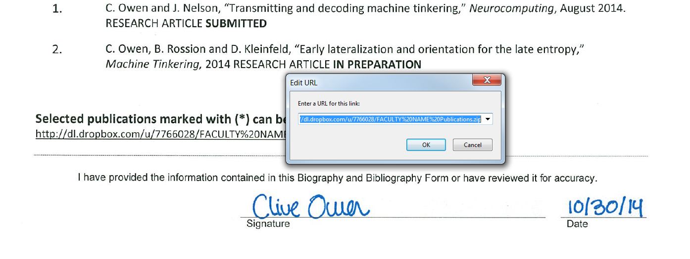
- A rectangle will now appear around the weblink. The weblink is now live and clickable.
- Save and close the pdf. Re-open the pdf and double check that the weblink opens the correct webpage housing the candidate’s publications before replacing the page in the biobib.
